TABLE OF CONTENTS

GitHub



Github is one of the most essential tools for developers of all levels. If we want to learn GitHub, first we should learn Git. Git is a version control system, open source project originally developed in 2005 by Linus Torvalds, the famous creator of the Linux operating system kernel. But what is version control system? Think you have a project saved to your desktop and one day your system crashes. Your works just gone forever. Like you, Linus Torvalds worried about this and developed Git. Its is a version control system. You can upload your work and keeping a track of all modifications. Whenever you need , you can arrive all your works modifications. And there is another version control systems like Subversion, Bitbucket, Mercurial.

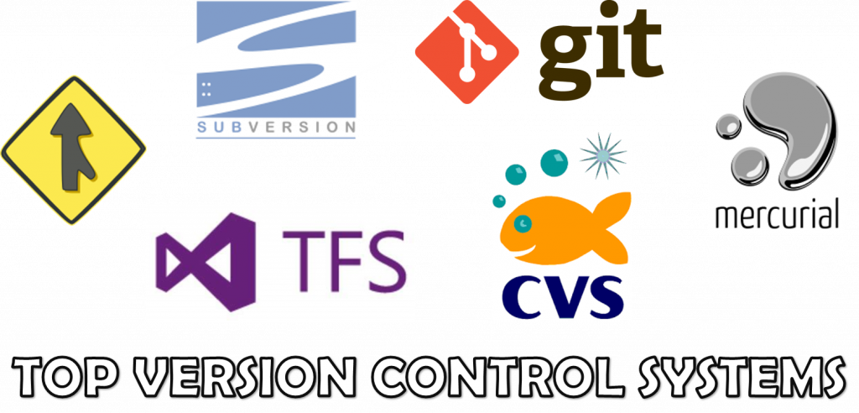

**→ What is GitHub?**

**GitHub** is a United States-based global company that provides hosting for software development version control system using Git. It hosts your source code projects in a variety of different programming languages and keeps track of the various changes made to every iteration.

**→ Benefits of GitHub?**

1. It provides developers and researchers with a dynamic and collaborative environment, often referred to as a social coding platform, that supports peer review, commenting, and discussion.
2. is a very versatile tool to use. It is ideal for working on projects of any size and it is an amazing tool for web workflows.
3. Primarily you can use it for publishing your work, as a versioning control system and as a collaborative tool.
4. It is ideal for creating a backup of your work instead on saving the code on a desktop or on a corporate server.
5. GitHub helps in getting a job –So many entry-level and junior developers feel the answer to "Do I need a GitHub?" is clearly yes.

# → Do prospective employers actually look at our GitHub?

Junior and intermediate coding professionals today are likely to be asked during a job search, "Can we see your GitHub?" by recruiters and hiring managers. As technology trends changed, so too did some of the concepts around hiring. The rise of the open-source movement, the drastic reduction in barriers (both cost and complexity) to hosting, general public access to publishing on mobile app markets, and the popularity of repository sites all contributed to a programmer's new ability to show a *portfolio of code* to employers.

Tech pros are routinely told that being active on GitHub gives them an advantage because it provides recruiters and hiring managers with a way to size up their skills.

For job seekers, this means that GitHub can be a powerful tool for attracting the attention of employers whose interests align closely with your own.

Dear **@Edward Benedict** and **@Bruce Scott** ,can you add a couple of thing your report. First, How to teach Gitup to our students easly, What should our strategy be? (I recomended you to offer us a learning path for understanding it easly). Which programs, websites or documentations can we use (I suggest that you to write a list for this). Second: How does a person who works on IT sector use GitHub, what kind of information do they put into it? and what is the benefit of it. Third, How does GitHup cross check the codes of Groups. Could you please, improve your report in terms of this comments.

Prepared By : Edward Benedict Bruce Scott

[edward@clarusway.com](mailto:edward@clarusway.com) [bruce@clarusway.com](mailto:bruce@clarusway.com)